Akhil Surapaneni

Feasibility Report

**Natural Wrist Tenodesis:**

Introduction

Currently, e-NABLE hands close when fishing line pulls on the fingers. This fishing line is tied between the top of the forearm (the tensioning block) and the fingers. When the patient rotates the wrist to flex their hand downwards, the distance between the fingers and the forearm increases. This in turn tightens the fishing line, which pulls the fingers closed. However, our biological hands naturally tend to close when the wrist is rotated so that the palm extends upwards.

ProblemDefinition

In order to mimic natural wrist tenodesis, the goal is to increase the distance between the tensioning block and the fingertips when the hand is extended upwards.

Solutions

Solution 1:

The simplest solution to this problem is to flip the gauntlet onto the bottom of the forearm. This way, the patient can tighten the fishing line by flexing the wrist upwards.

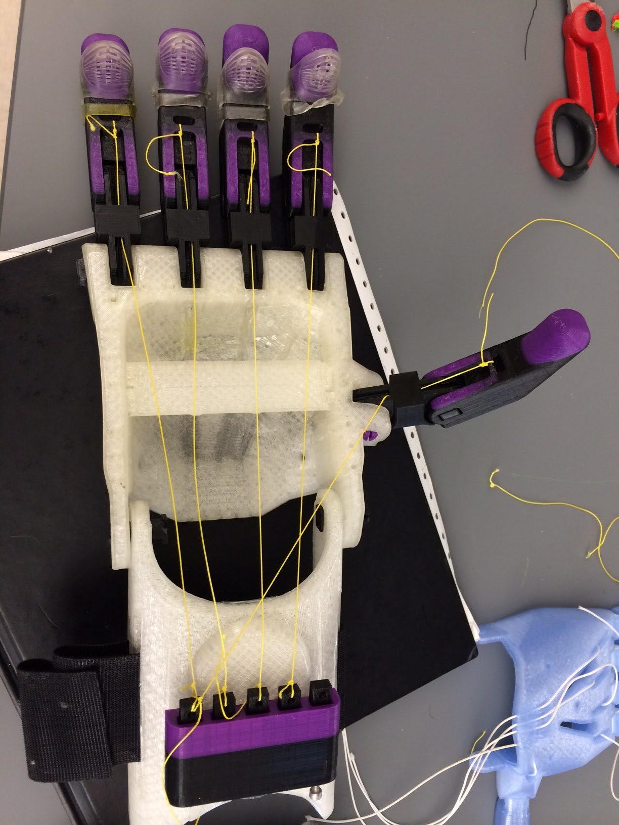

We have demonstrated a proof of concept of this method.

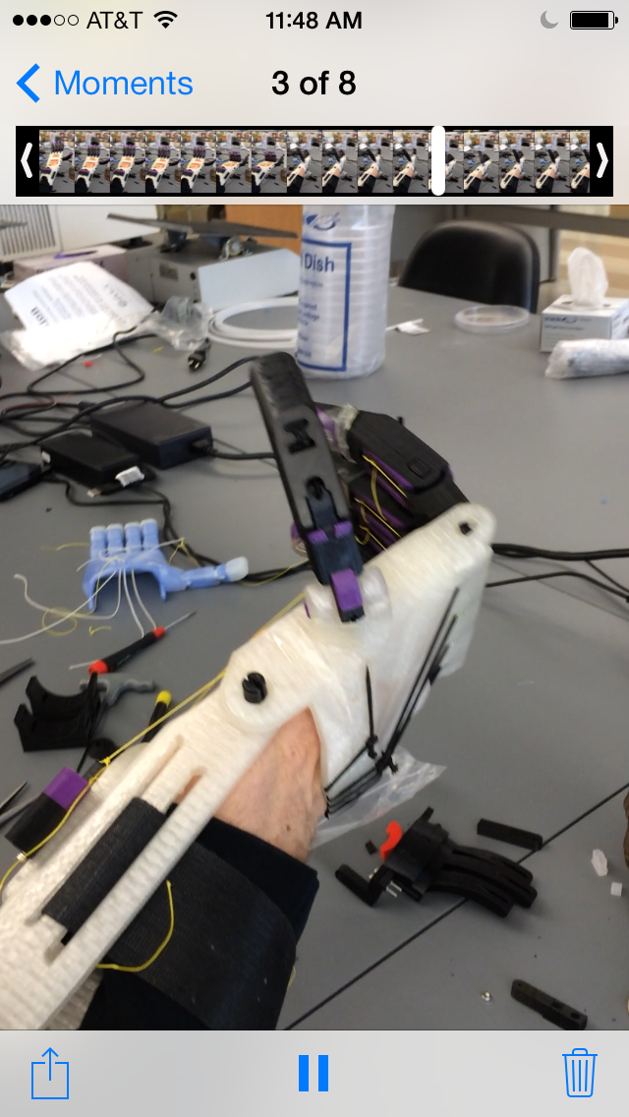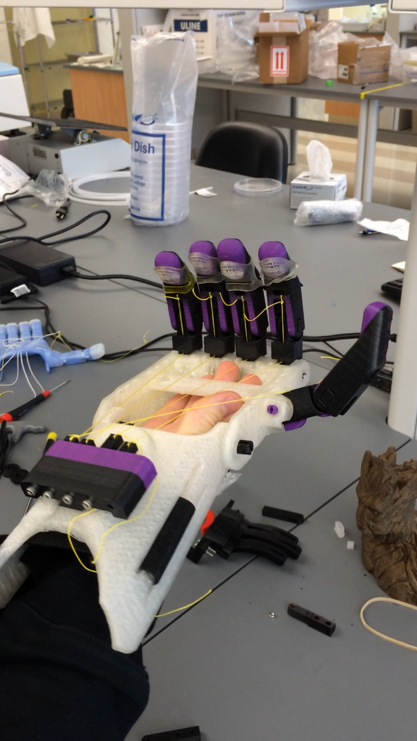

However, there are several flaws with this simple solution:

1) The fishing lines get in the way of the patient’s palm. This means, that whenever the patient is holding something, that object can tug at the fishing line.

2) If we were to solve the above problem by building a case around the fishing lines, then when gripping an object, the patient would lose the tactile feedback of the object against their palm.

Solution 2:

One way to avoid the complications discussed in solution 1 is to route the fishing wire through the side walls of the hand as seen in the diagram below.

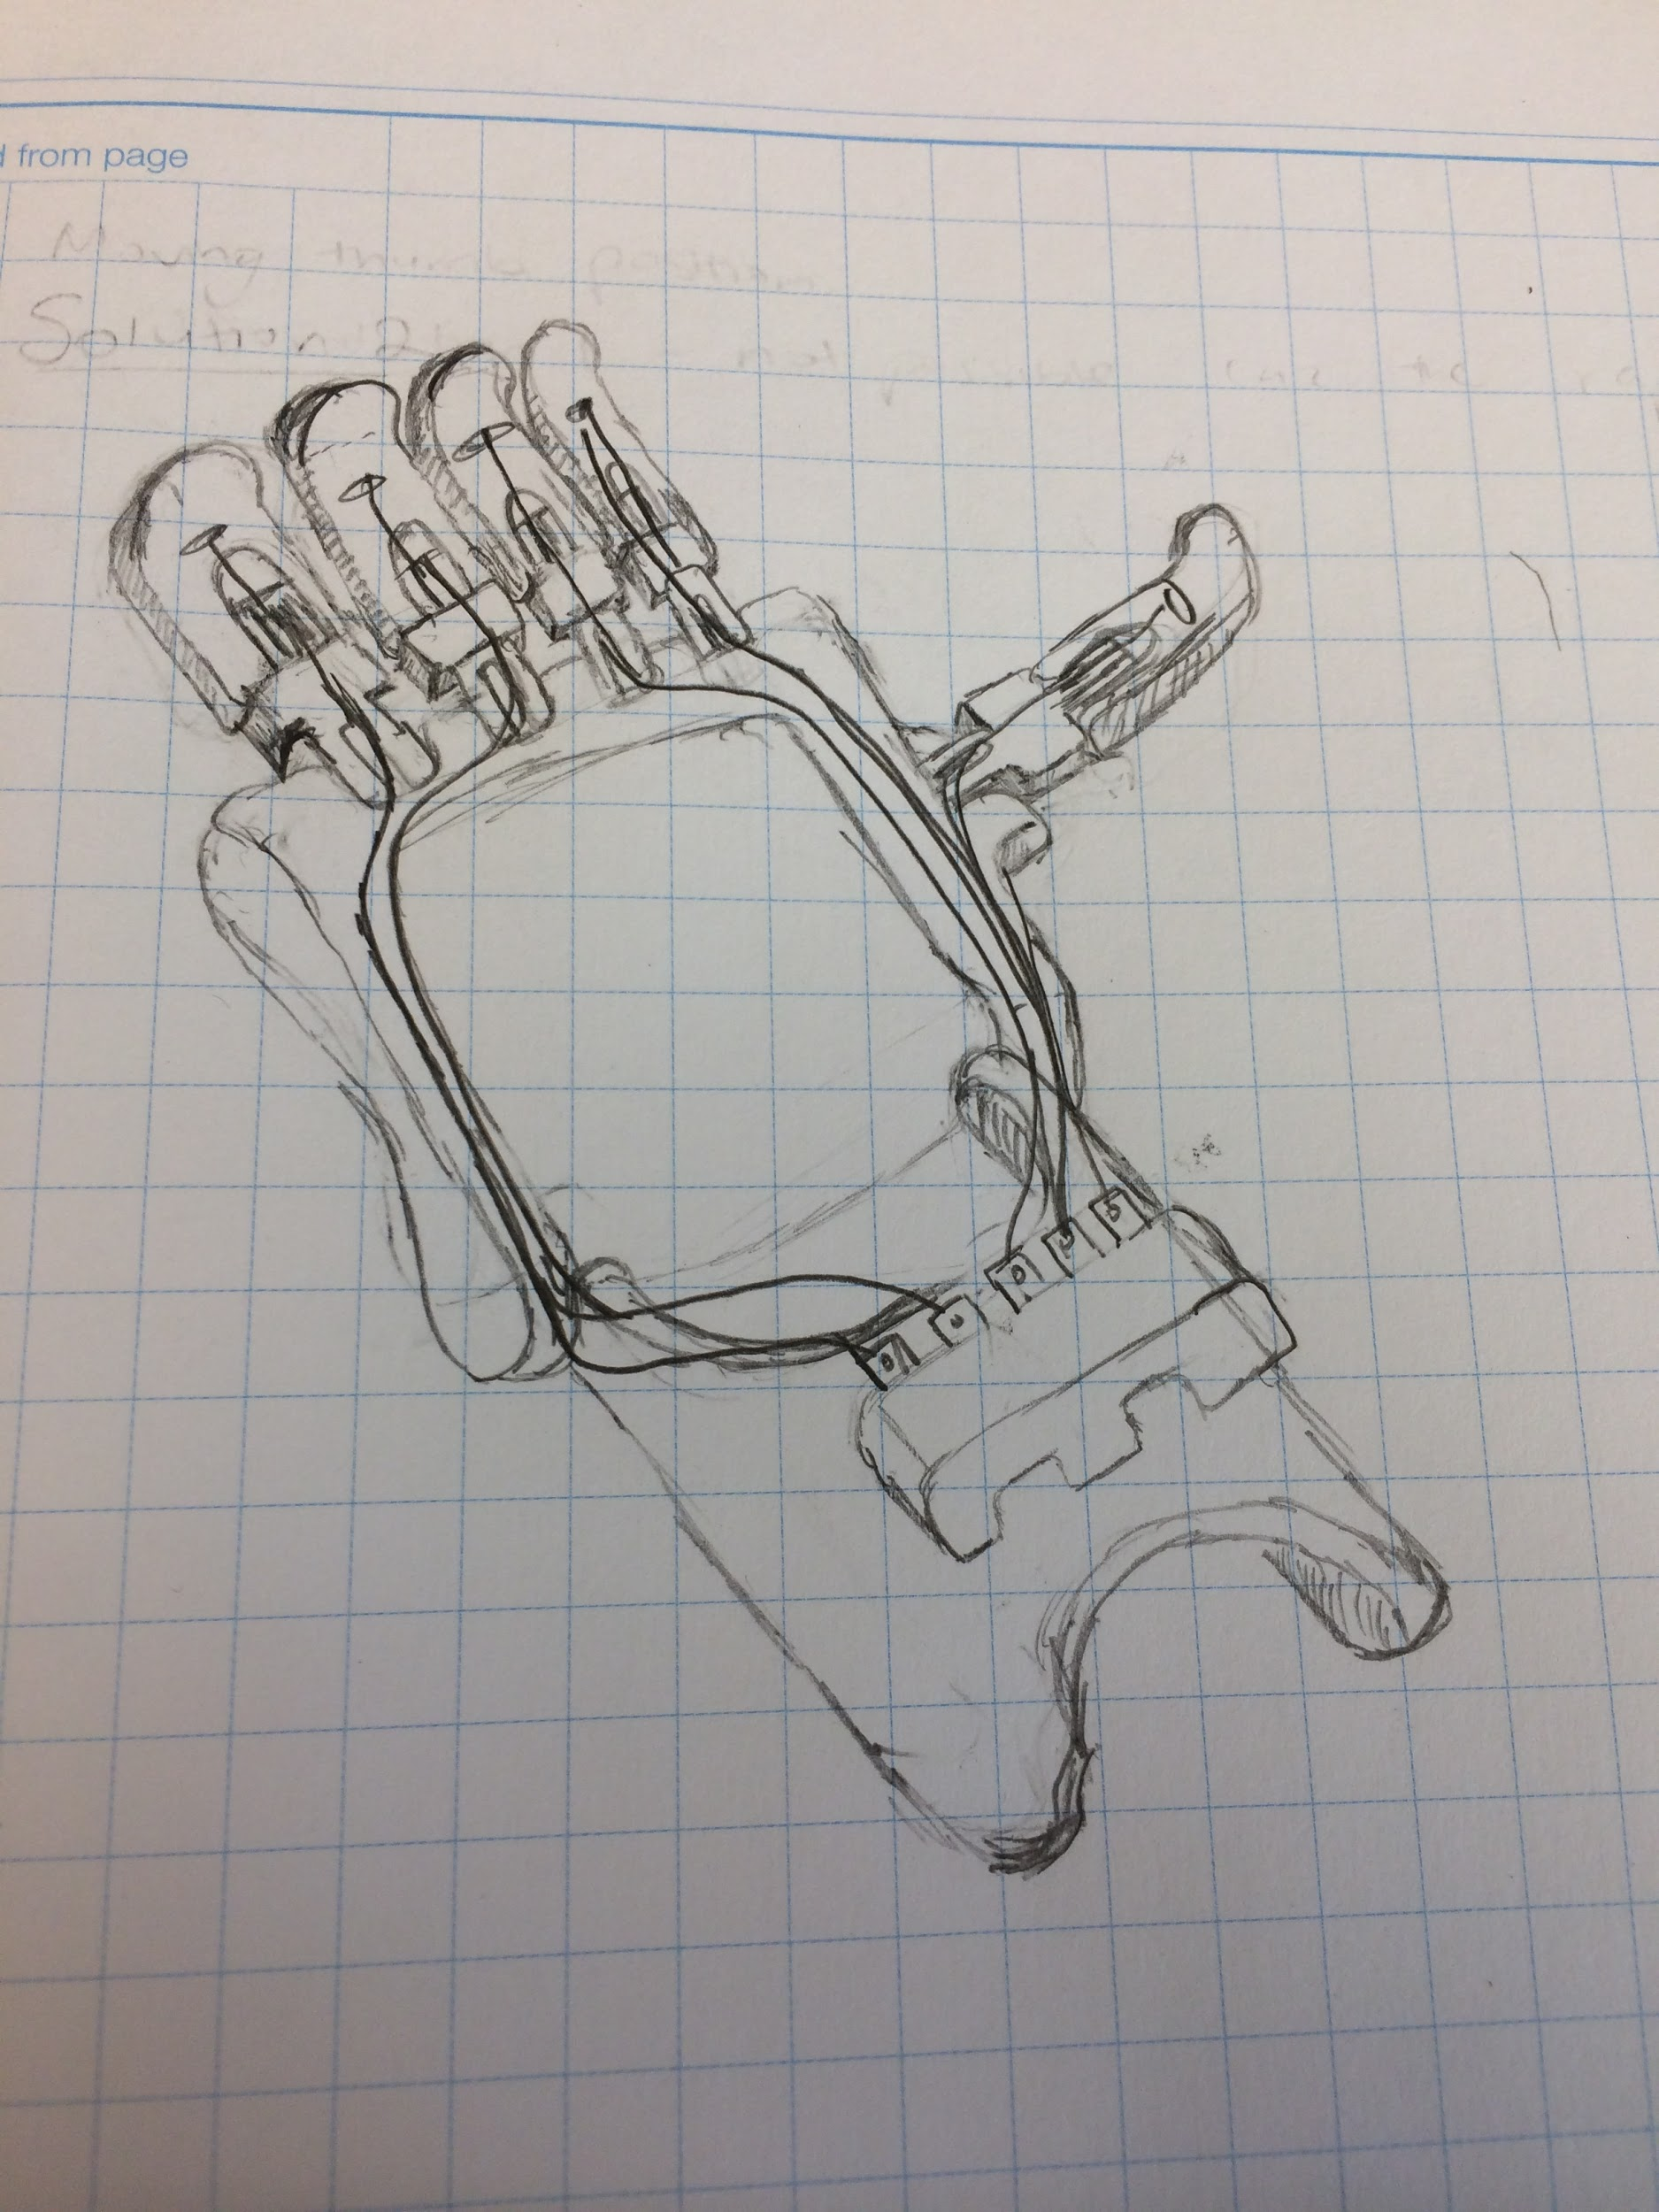

The above solution has a disadvantage because there is an increase in drag on the cabling when it makes turns around the plastic.

Solution 3:

It is possible to still keep the tensioning block on the top of the forearm as long as the tensioning block itself moves when the wrist is extended upwards. The diagram below gives the details of a proposed design that does just that. The tensioning block is set on a rotating hinge. When the wrist is extended upwards, the bottom of the tensioning block is pulled, causing the block to rotate backwards and increase the tension on the fishing line.

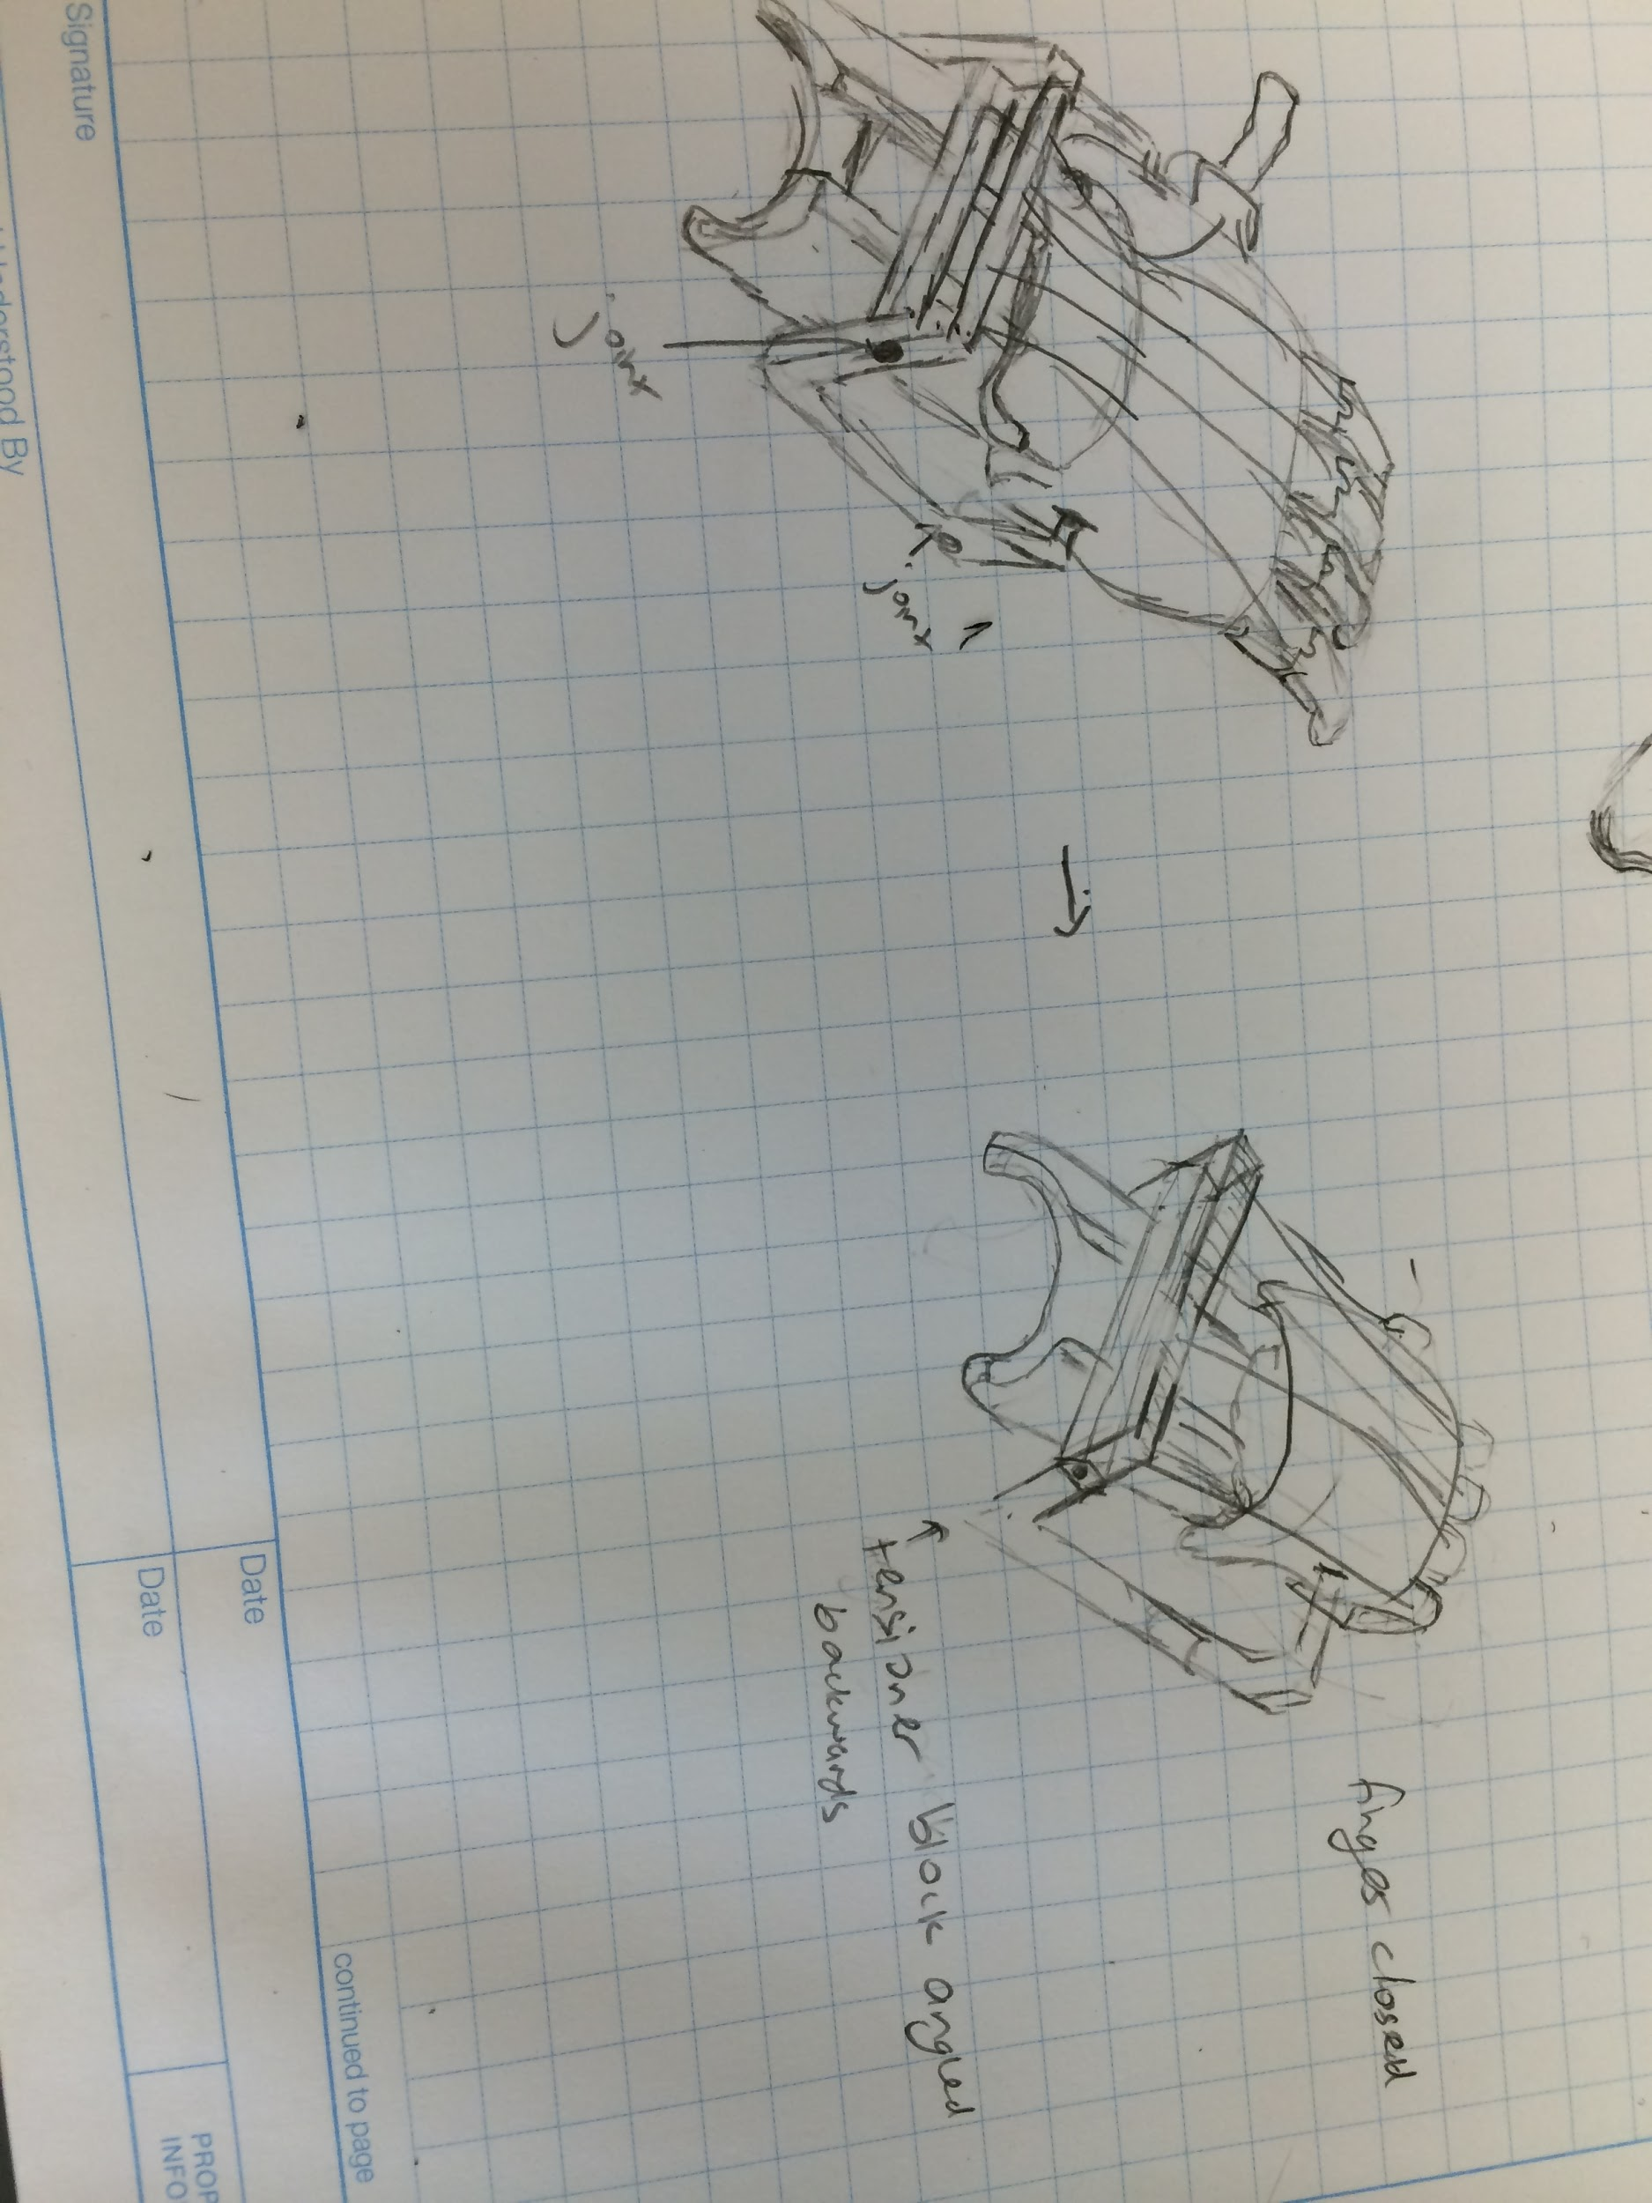

The disadvantage to this design is that there are a lot of moving parts, which increases the risk of something going wrong.

**Proper Thumb position**

Introduction: The thumb placement on e-NABLE hands is not anatomically correct, which poses problems to patients who are trying to grasp objects.

Problem statement: The hinge joint on the palm for the thumb needs to be rotated 30 degrees about the z axis in order to achieve anatomical accuracy. In order to measure the angle of rotation, I examined the Raptor Reloaded and a design that has the correct thumb angle, called the Flexyhand. I then flexed the thumb of the Raptor Reloaded until it was in line with the natural thumb angle on the Flexyhand. I measured this angle to be 30 degrees.

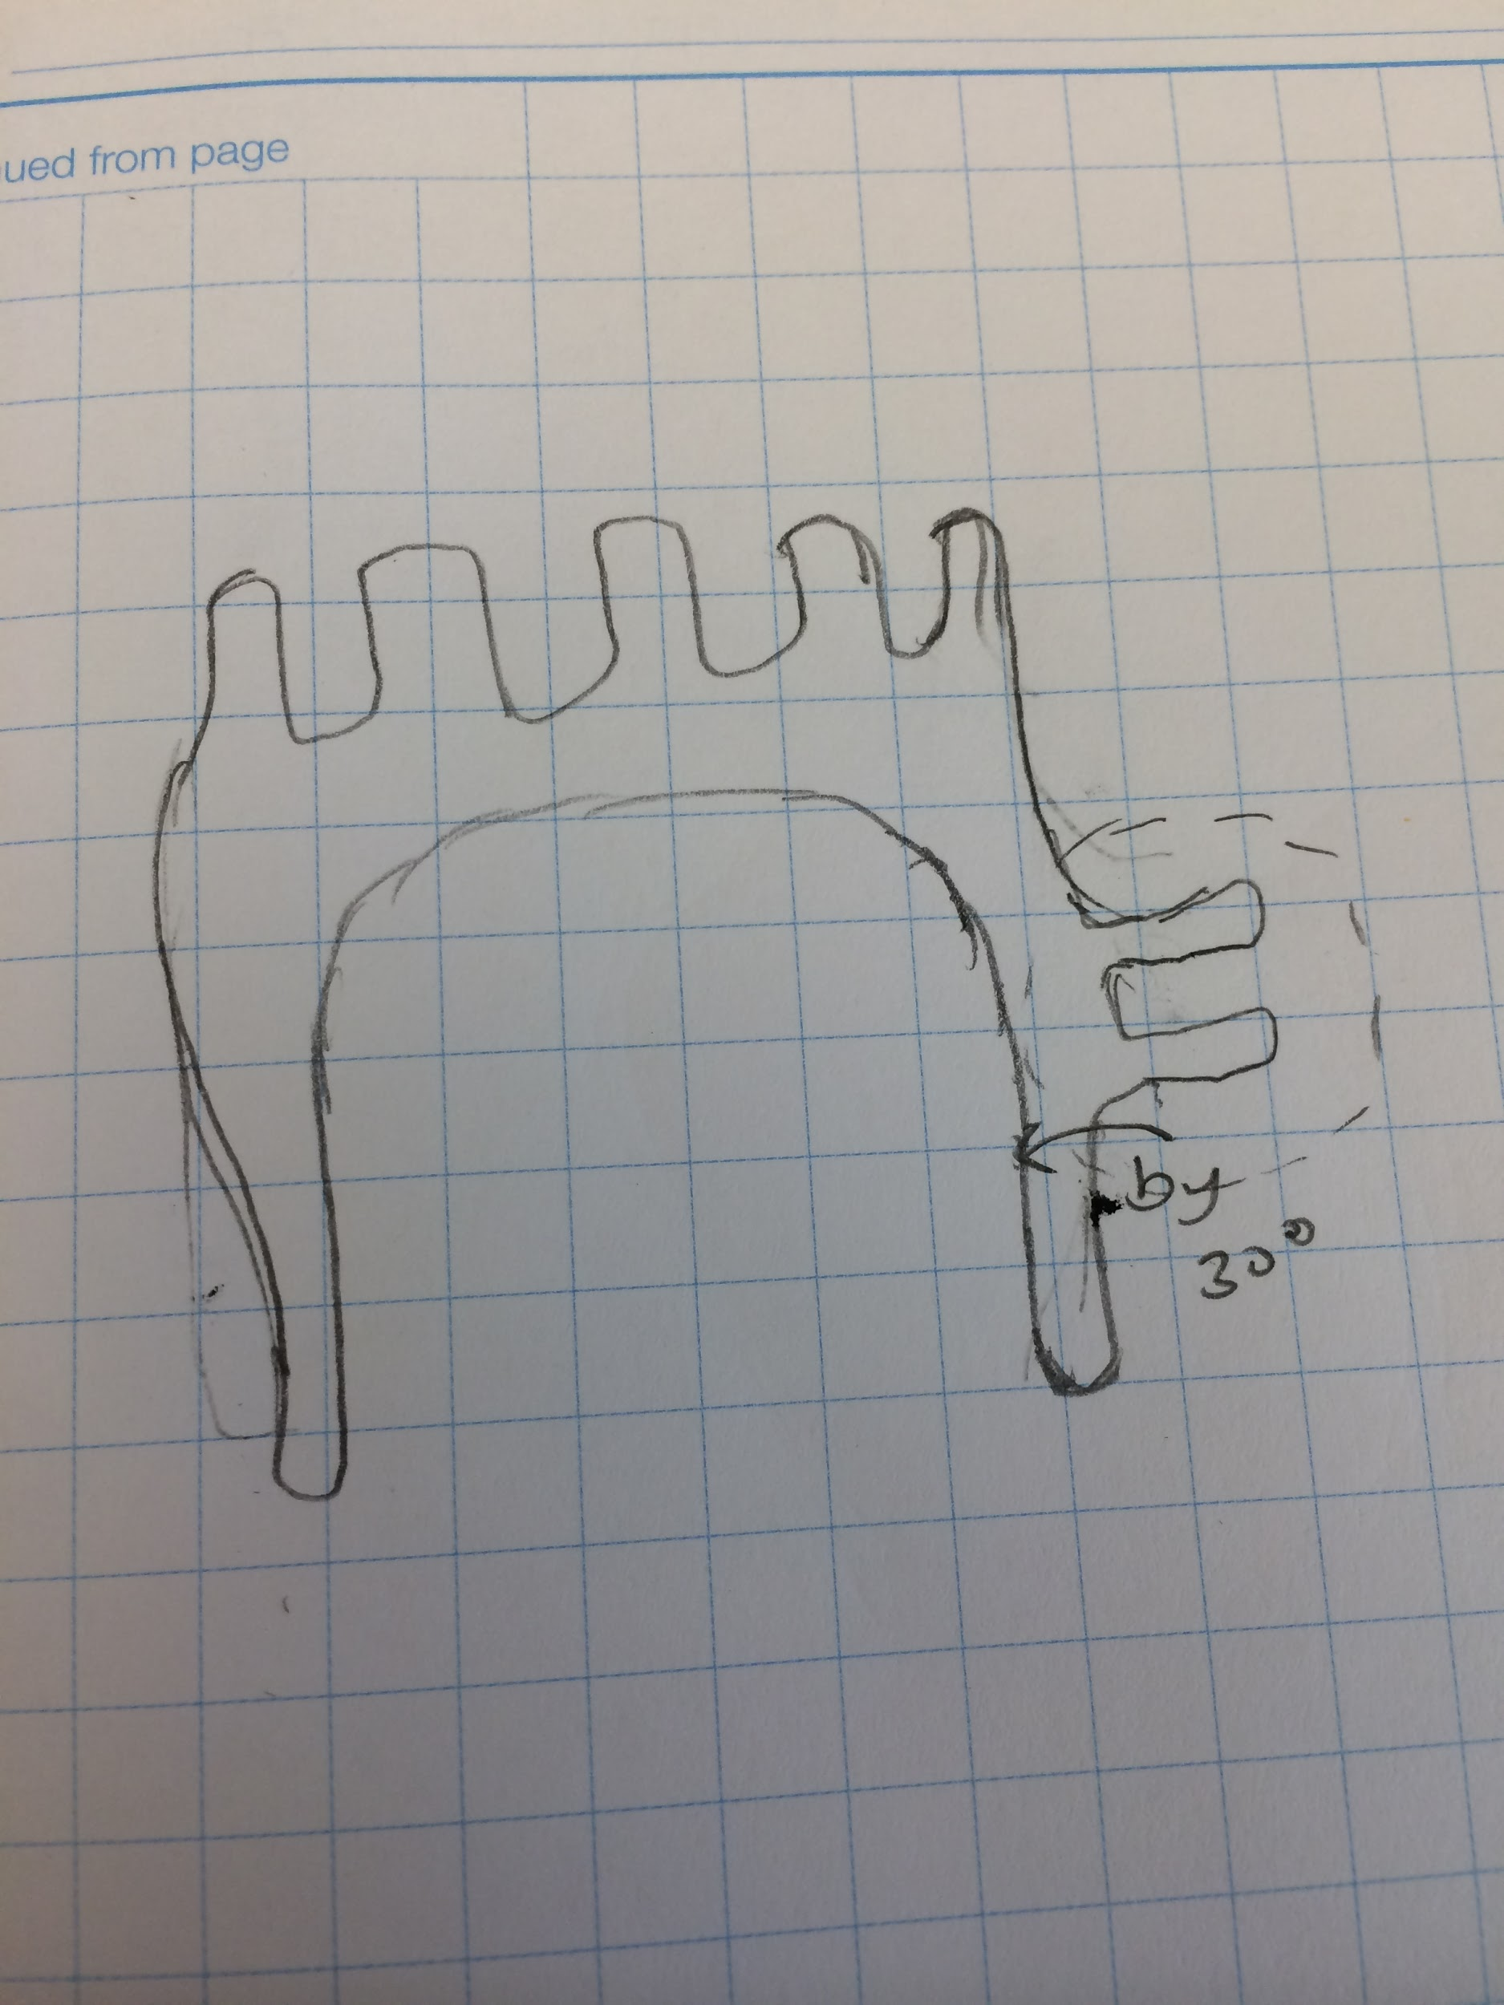

There are four ways of creating a new thumb and I have ordered them below by increasing complexity.

Solution #1 is modify the existing Raptor Reloaded .stl’s to change the thumb angle. However, after combing through the .stl’s, I could not find any parameter that allowed me to change the thumb angle. This solution is not feasible.

Solution #2 is to design a new thumb with a fixed angle that is anatomically correct. This has already been done by Gyrobot, a mechanical design company in the UK, in their flexy hand design.

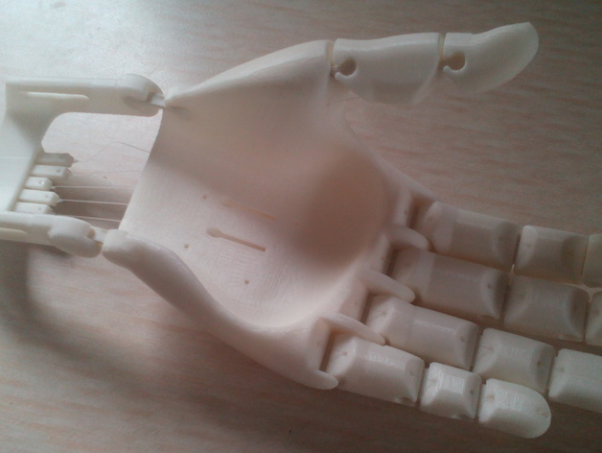

Solution 3 is to design a palm in which the user can physically rotate the thumb to change the angle. This would add a layer of complexity but can be done by designing a hinge around which the thumb hinge can rotate. In a further meeting with Dr. Gogola, I will ask her whether the ability to change the thumb angle, between the current Raptor Reloaded angle and the anatomical angle, is beneficial.

Solution 4 is to design a palm in which the user can parametrically change the thumb angle. After investigating Fusion 360, I’ve discovered that while the angle of an object can be changed, it leaves a huge void where the object used to be before the angle change. So, this solution is not feasible.

**Partial Fingers**

Introduction: Currently, e-NABLE hands are not customizable to accommodate patients with partial fingers. They don’t have a slot on the between the fingers where the patients can slide their partial fingers into. The knuckle pins on the existing Raptor Reloaded design would protrude into the patient’s partial finger. Furthermore, they don’t have a device that will extend the patient’s partial finger to the reach of the other fingers so that they can all close at the same time.

Problem statement: This design challenge can be split into two parts.

Part 1: Create a hand in which the user can parametrically create a slot for the patient’s partial finger. The current Raptor Reloaded model doesn’t have a parameter that defines the width between two fingers, so I would have to make a new palm design

Part 2: Create a parametric extension for the partial finger so that the partial finger can become the same length as the other fingers. This extension should be powered with the partial finger

Solutions:

For part 1:

Solution #1: Create a palm on Fusion in which you can make gaps for the partial finger. This can be done in fusion 360 by joining finger “segments”, which are defined as the distance across a finger plus half of the gap between the finger on both sides.

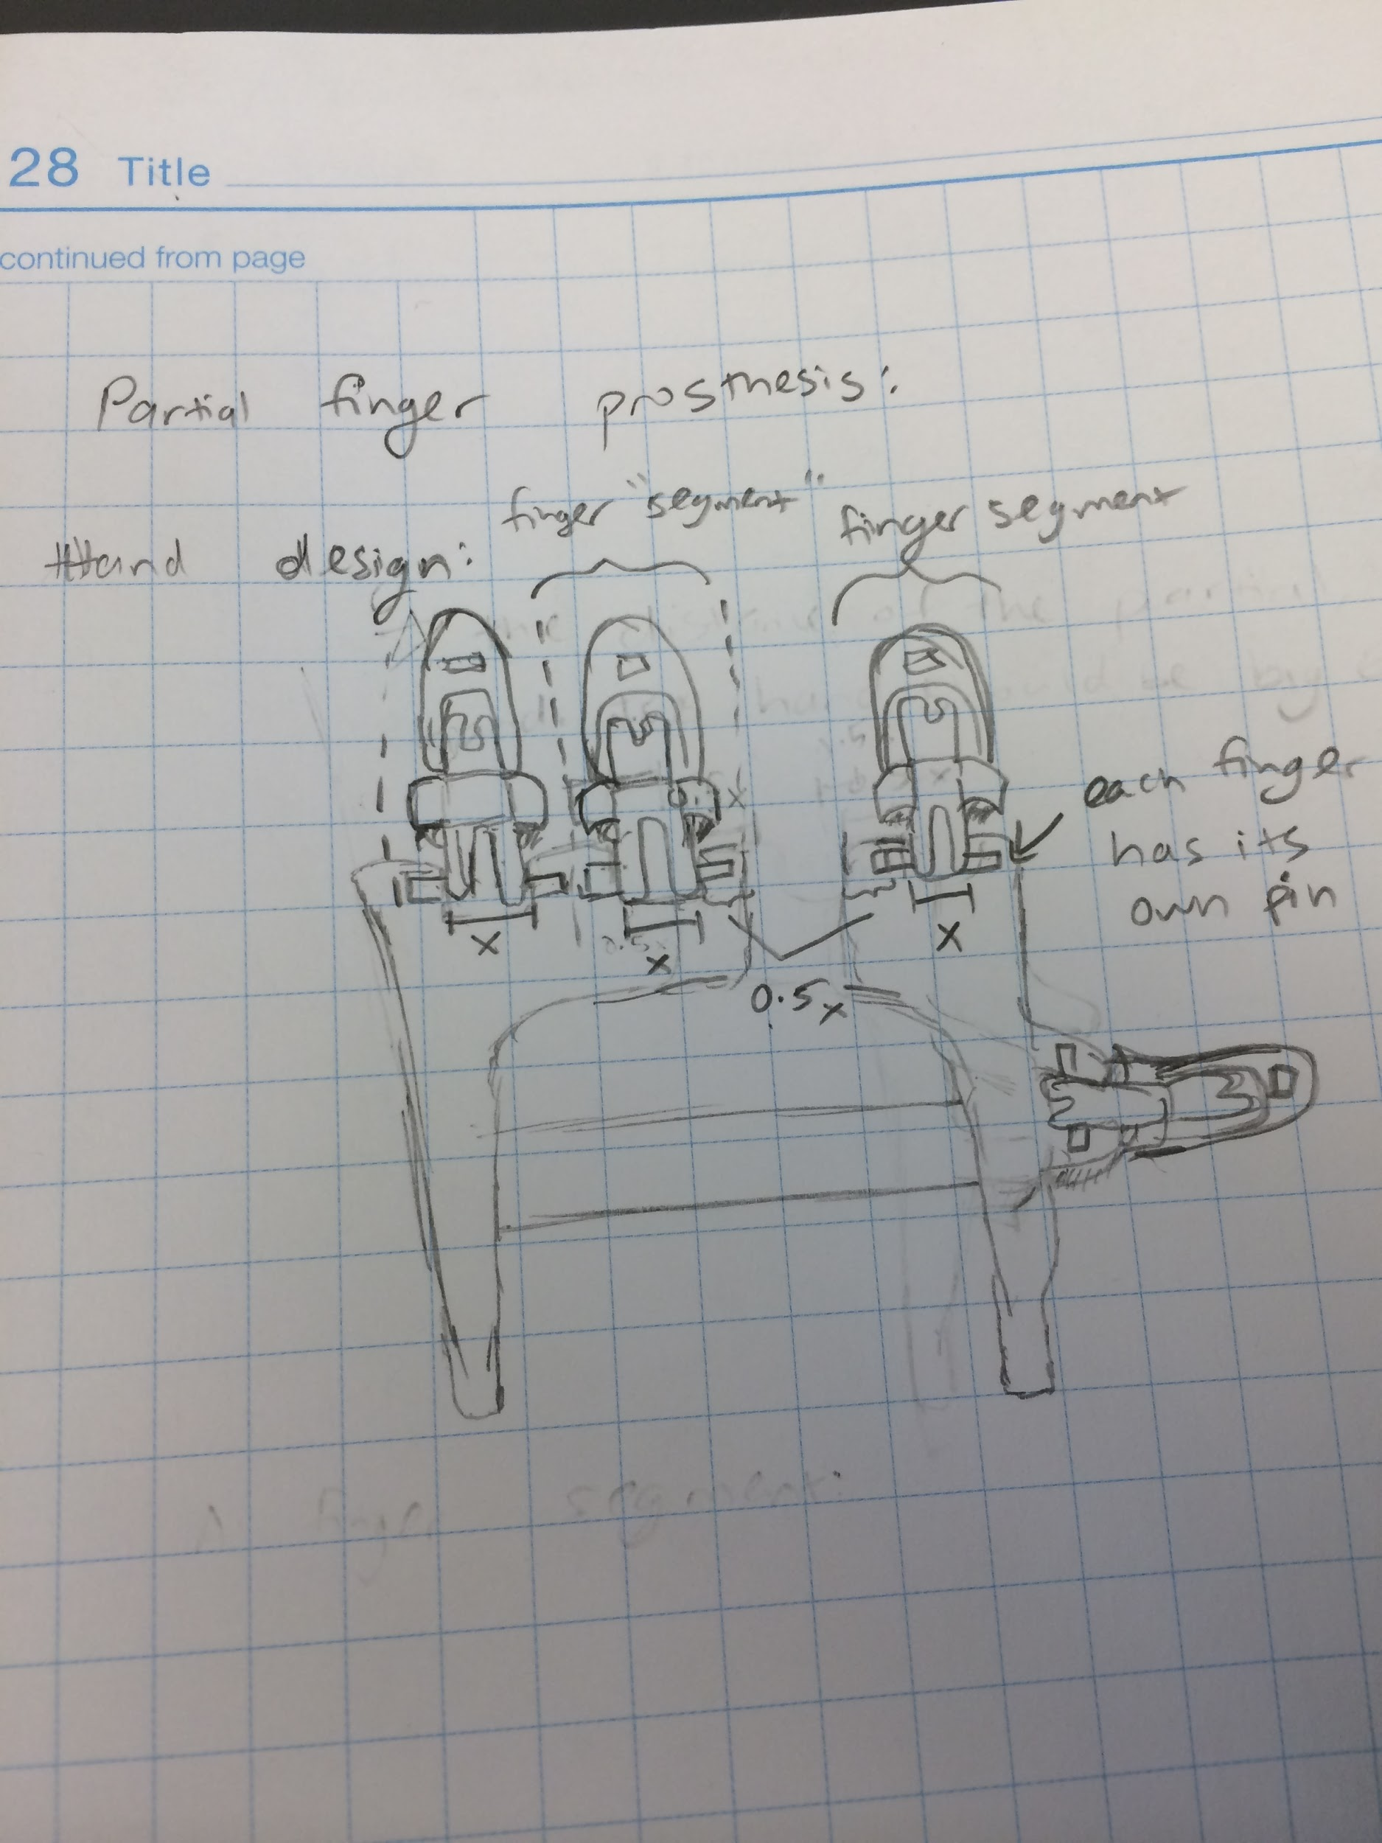

The size of the partial finger helps define the size of the hand. The hand should be big enough so that the gap for the partial finger is big enough, even if it means the hand is a little bigger than the recommended palm size.

For part 2:

Solution #1: If the patient has enough strength to move his or her partial digit, then flexion of the extender digit can be powered by rotation of the partial finger. If we tie a fishing line between the extender digit to a slot right above the palm, as seen below, then the patient simply has to move his or her partial digit downwards to increase the tension in the fishing line, causing the extender digit to rotate. 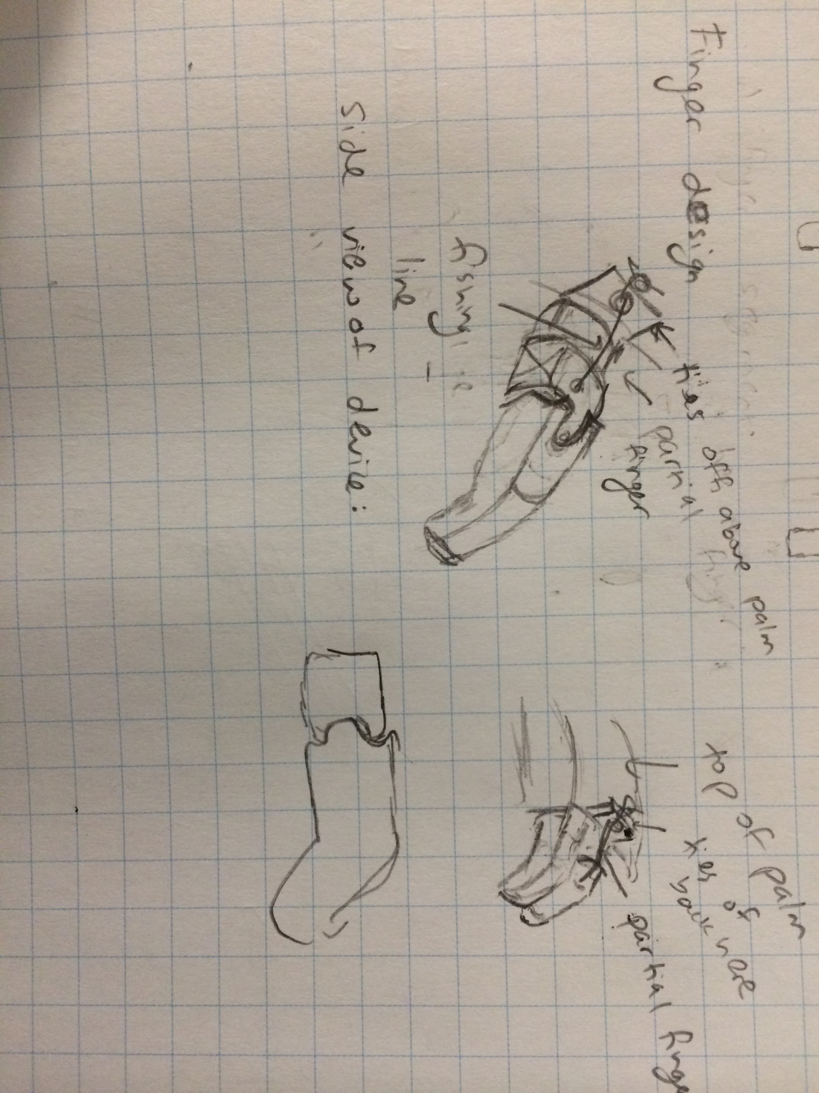

A proof of concept test has been done to show that the partial finger does have enough power to flex the extender digit. The result is shown in the figure below.

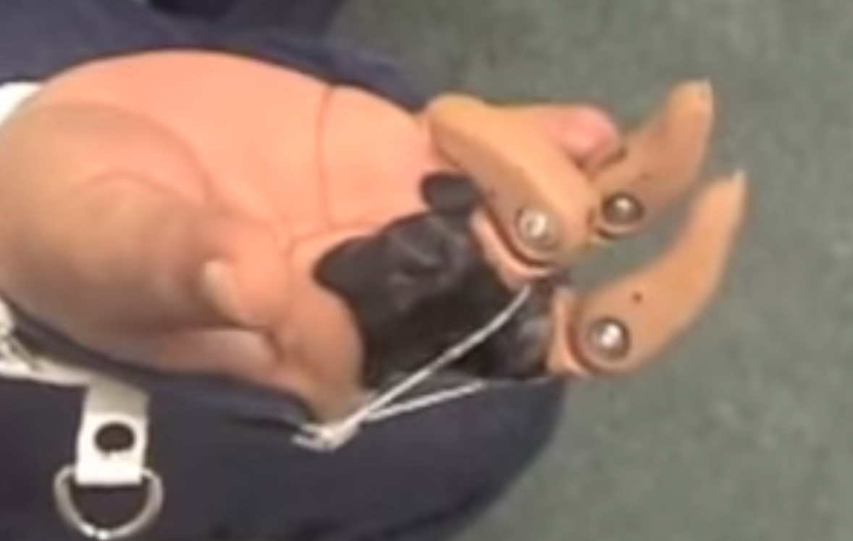

Solution #2: We can use the same partial finger design as in Solution #1, but instead, we can tie the fishing line to the same tensioning block on the gauntlet that the fishing line from the other fingers tie off to. This solution would be used in case the patient does not have enough mobility in their partial finger to flex the finger about the interphalangeal joint.

**Multiple Grips**

Introduction: Currently, e-NABLE hands have only two modes: extension of all the fingers, or complete flexion of all of the fingers. This means that they can only do one grip. However, we need different grips for picking up different objects. We need a cylindrical grip to pick up a water bottle, but a spherical grip for holding a ball. We need a key pinch to operate keys, while we need a tip to tip grip to pick up small objects. While there are many more grips than the the four basic ones I described here, we would need to build a myoelectric hand to incorporate all of them. However, there is a need for a hand that can toggle between these four basic grips.

Problem statement: In order to toggle between grips, we need to differentially change the tension on the fingers. If, for example, the index finger has more tension than the thumb finger, then it will close faster than the thumb. So, instead of the tip of the thumb meeting the tip of the index finger, the tip of the thumb will touch the middle of the proximal phalange. This forms the physical basis to differentiate between tip to tip grasp and key pinch grasp.

This problem can be broken down into two parts. The first part is switching between cylindrical and spherical grip. The second part is switching between key pinch and tip to tip grip.

Part 1

Solution 1: Depending on the object, the patient should be able to switch between cylindrical and circular grip. This problem has already been solved in the e-NABLE community. A mechanical design company called Gyrobot published an open source hand design using a reverse whipple-tree mechanism to achieve adaptive grip.

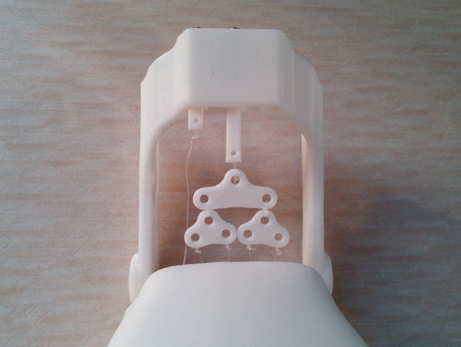

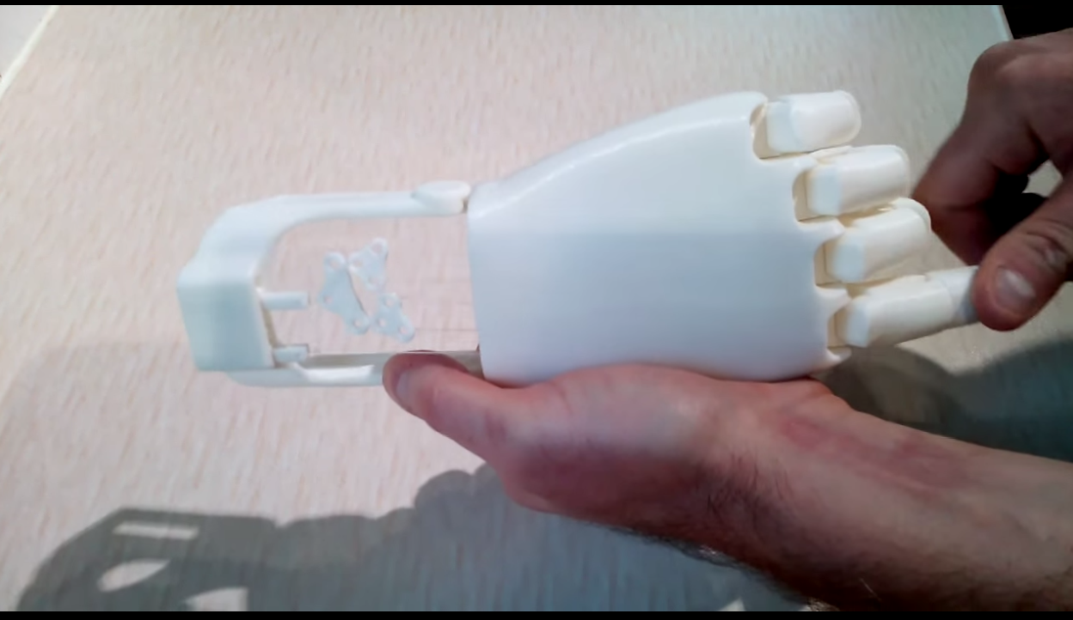

A whippletree mechanism is used to distribute force from uneven pull across multiple linkages into a uniform single force at the load. Here, we are using a reverse whippletree to cause uneven pull across the fingers (causing differential tension in the segments) by a uniform single force by flexing the wrist. A reverse whipple tree allows the fingers to flex until they encounter an object. So, if the user was trying to hold a cylindrical object, the fingers would flex differently than if the user was trying to hold a spherical object.

Part 2:

Solution 1: In order to switch between key pinch grip and tip to tip grasp, we must adjust the tension on the thumb. If the thumb has more tension than the index finger, then the hand will close into key pinch grip If the thumb has the same tension as the index finger, then the hand will close into tip to tip grip. To adjust the tension, we can use a guitar peg mechanism on the thumb.

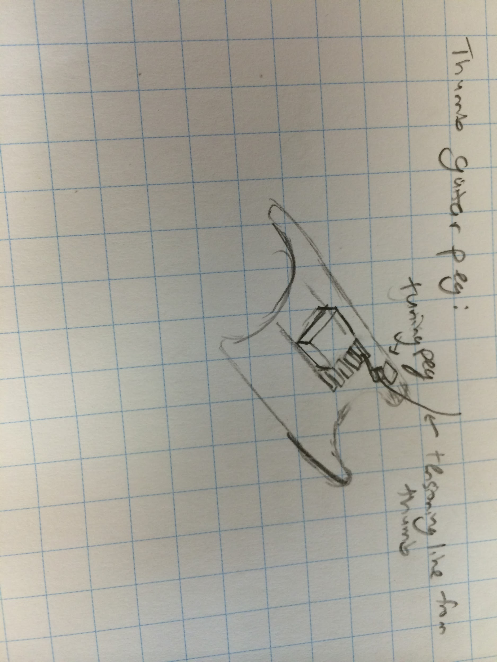

I have demonstrated proof of concept of this design by wrapping tensioning cord from the index finger around a screwdriver. The screwdriver acts as my tensioning peg in this case. By rotating the screwdriver, I can increase the tension in the finger.

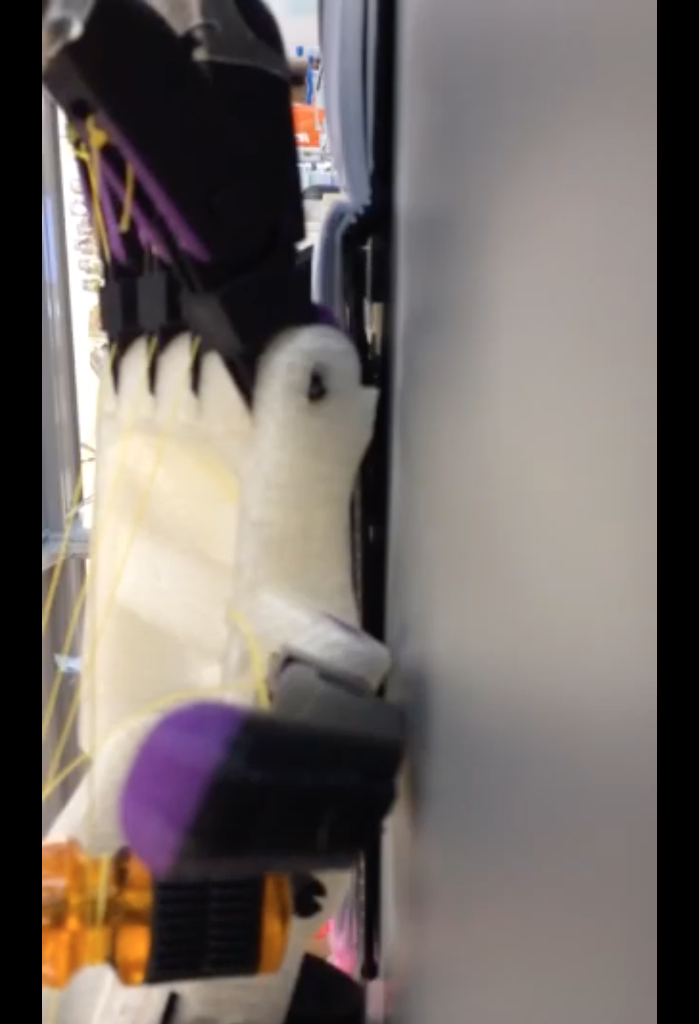

A disadvantage in this design is that adding a tuning peg would increase complexity because there are more moving parts. Additionally, it’s more time consuming to change tension because the user has to wind the tuning peg just the right amount.

Solution 2: Instead of having a tuning peg that the user can rotate to increase tension, a simpler solution would be to place a stationary peg to the side of the tensioning block. When the fishing line routes through the stationary peg, the tension on the thumb is increased because routing through the peg adds distance from the thumb to the tensioning block. This solution is easier to use for the patient as well because he or she just has to slip the string around the the peg to switch between key and tip to tip grips.

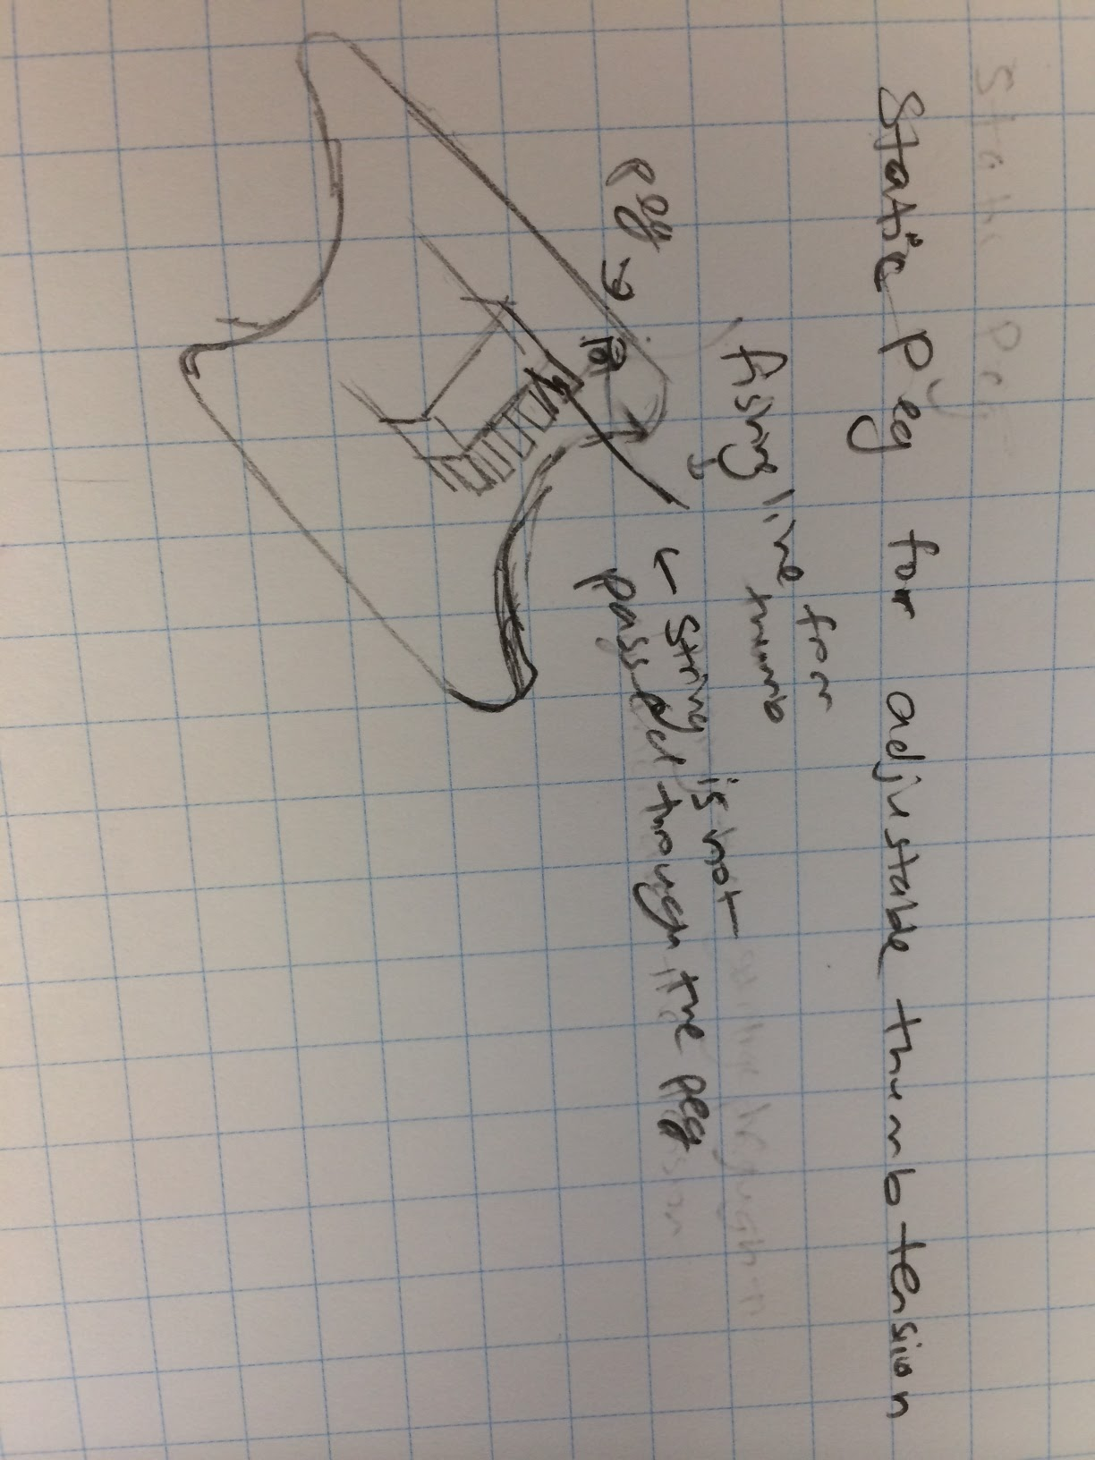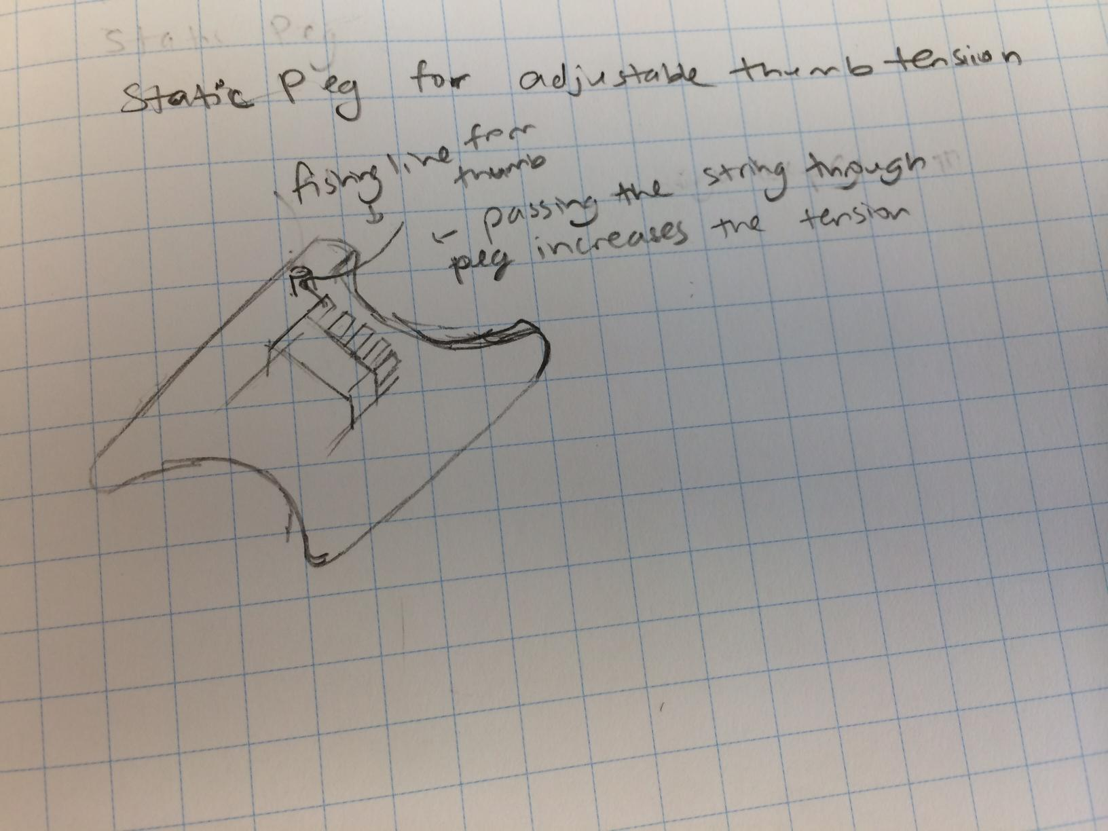

A proof of concept for this design is shown below.

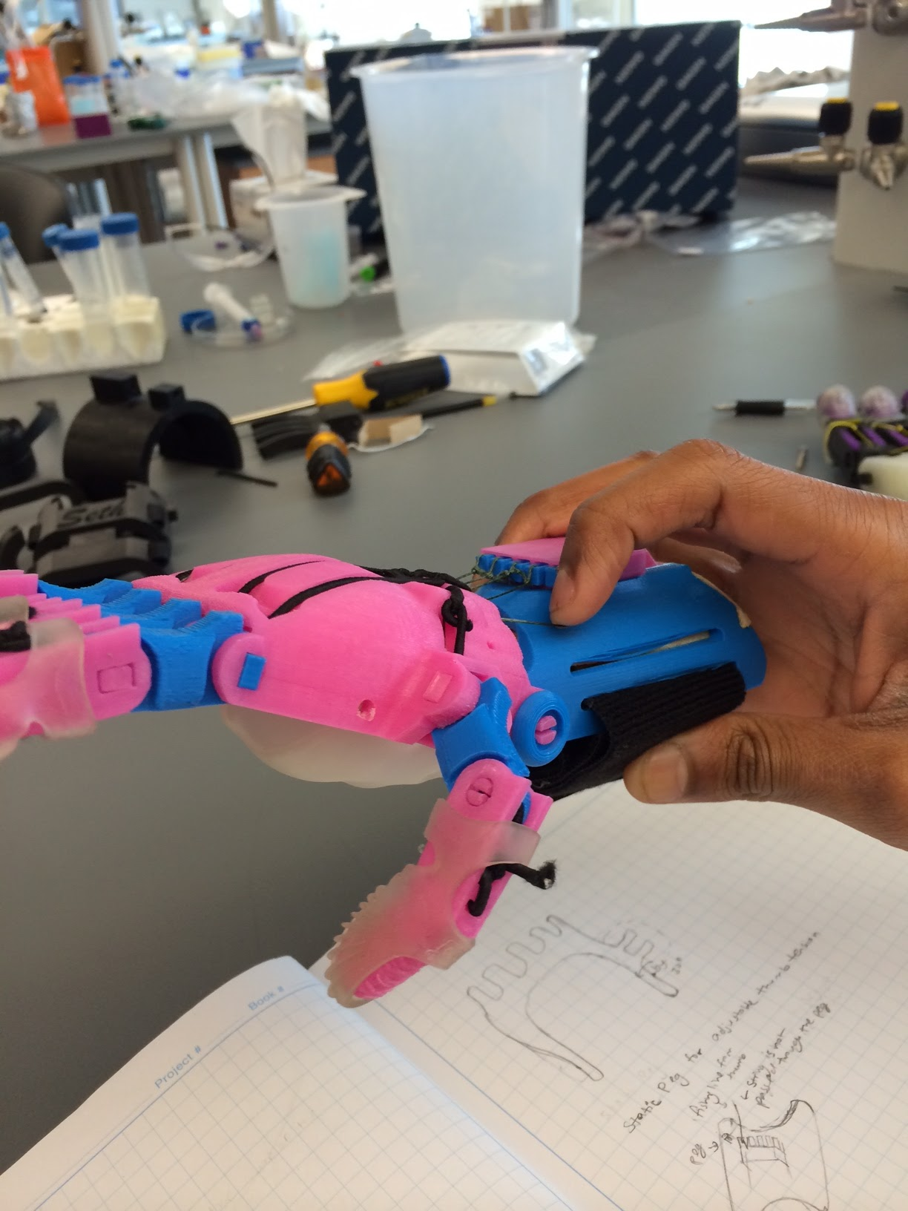

The position of my index finger acts as a stationary peg and increases the distance that the cord has to travel.